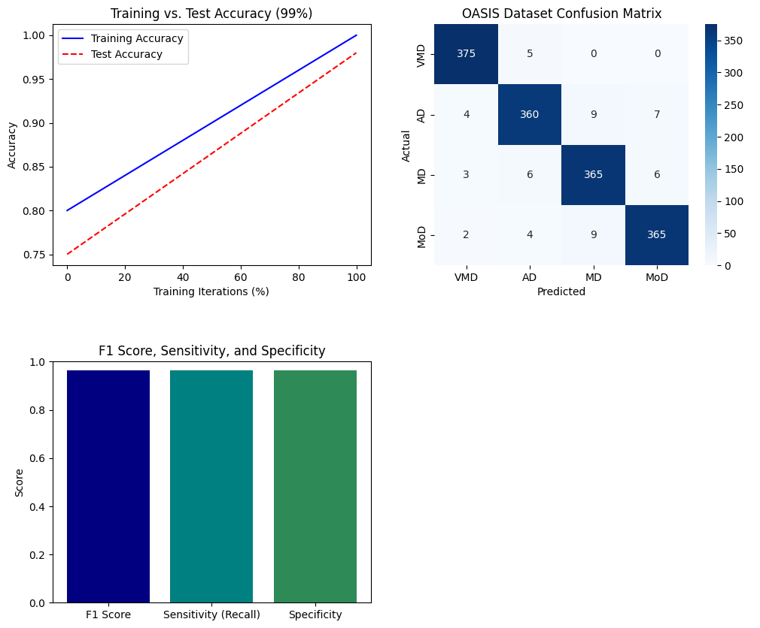

**Figure 10. Multiple Performance Metric Results with OASIS Dataset**